Test Case: tc002_SPX_Dev5_Crear_Requisicion_Spot_Con_FAD_Tipo_Cobro_CC
Step 1 - Enter username and password and click to button Enter : Credentials Entered
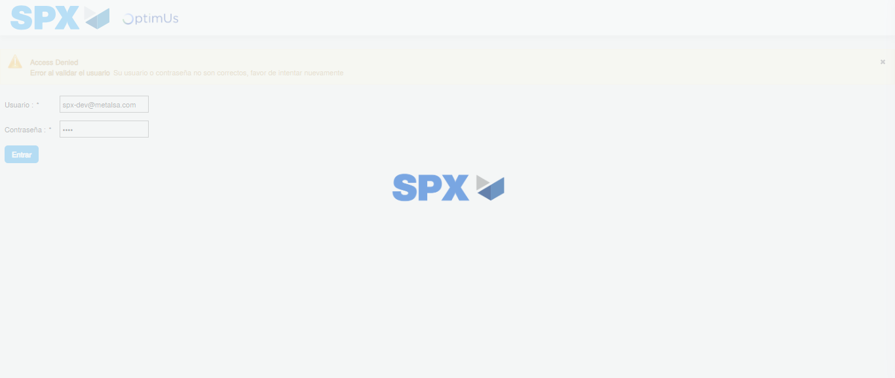Image file-name: QC_Testing-tc002_SPX_Dev5_Crear_Requisicion_Spot_Con_FAD_Tipo_Cobro_CC-1785975440856

Step 2 - Select to UEN and Access to Spot Buy Requisitions : UEN Correctly selected and Correct access
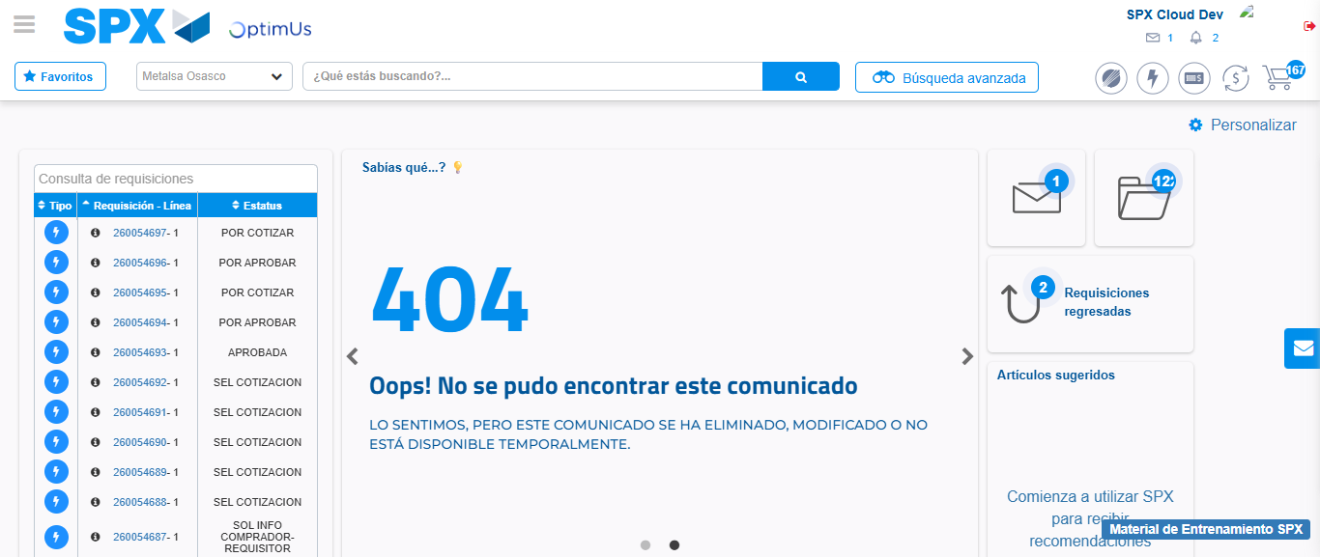Image file-name: QC_Testing-tc002_SPX_Dev5_Crear_Requisicion_Spot_Con_FAD_Tipo_Cobro_CC-1785975467027

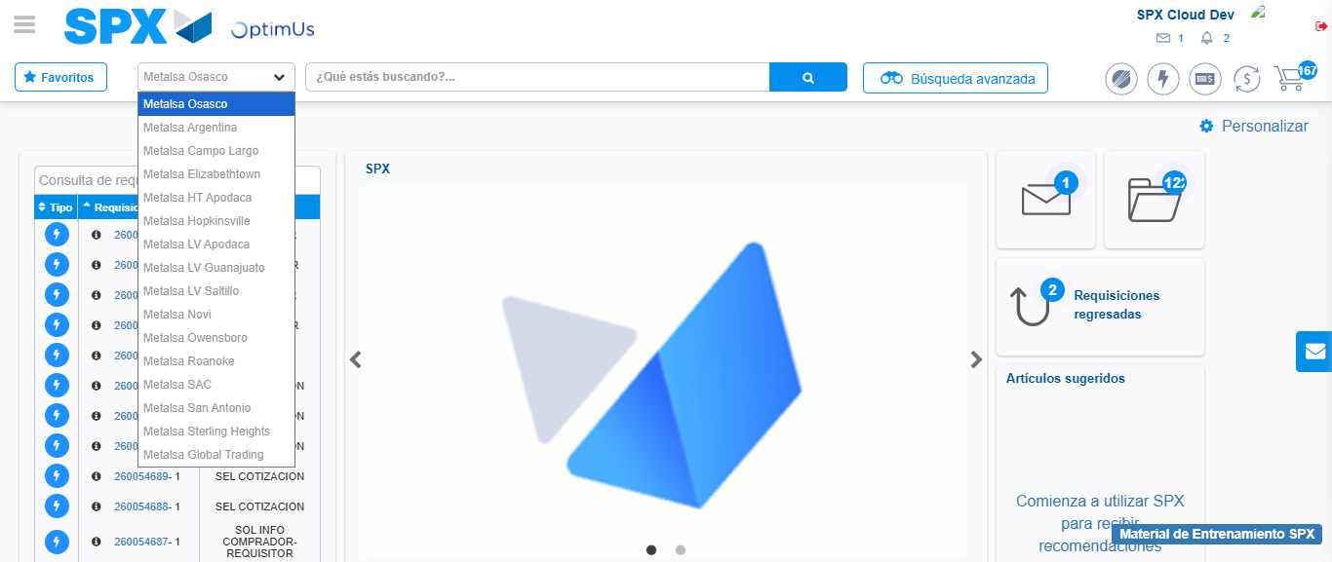Image file-name: QC_Testing-tc002_SPX_Dev5_Crear_Requisicion_Spot_Con_FAD_Tipo_Cobro_CC-1785975470164

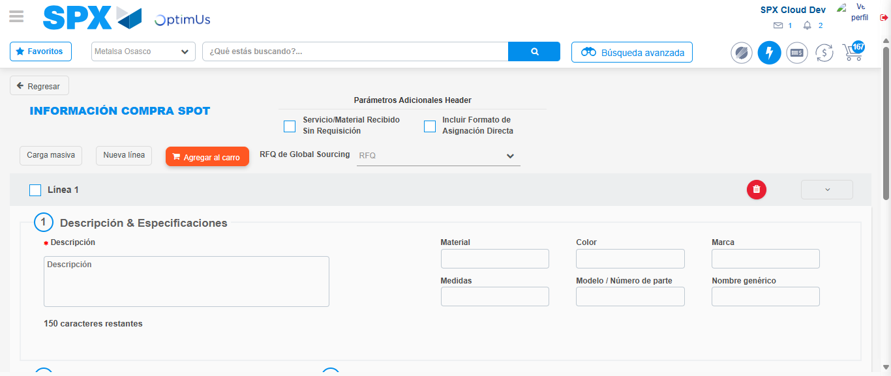Image file-name: QC_Testing-tc002_SPX_Dev5_Crear_Requisicion_Spot_Con_FAD_Tipo_Cobro_CC-1785975476714

Step 3 - Add FAD to Requisition: FAD Successfully Added
Image file-name: QC_Testing-tc002_SPX_Dev5_Crear_Requisicion_Spot_Con_FAD_Tipo_Cobro_CC-1785975477013

Image file-name: QC_Testing-tc002_SPX_Dev5_Crear_Requisicion_Spot_Con_FAD_Tipo_Cobro_CC-1785975477220

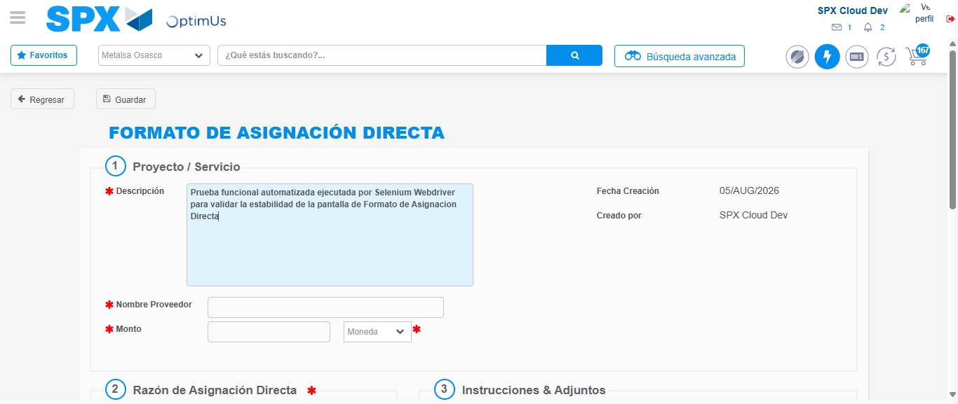Image file-name: QC_Testing-tc002_SPX_Dev5_Crear_Requisicion_Spot_Con_FAD_Tipo_Cobro_CC-1785975480262

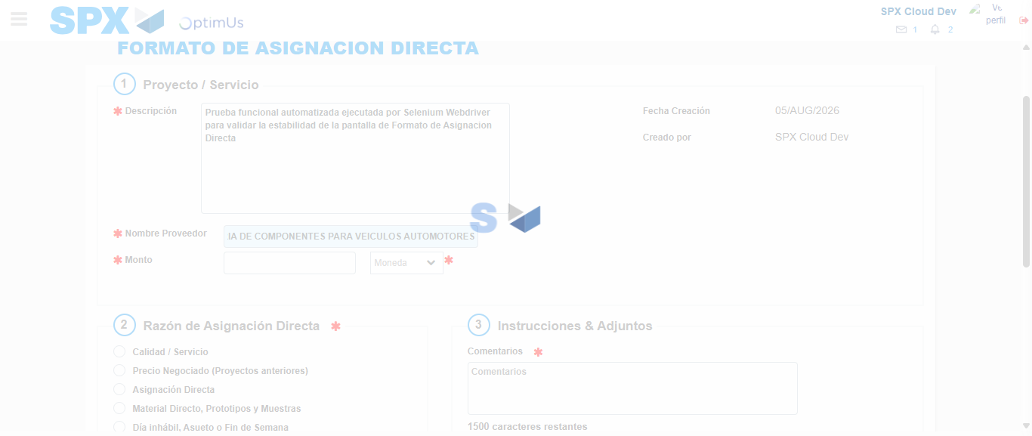Image file-name: QC_Testing-tc002_SPX_Dev5_Crear_Requisicion_Spot_Con_FAD_Tipo_Cobro_CC-1785975490822

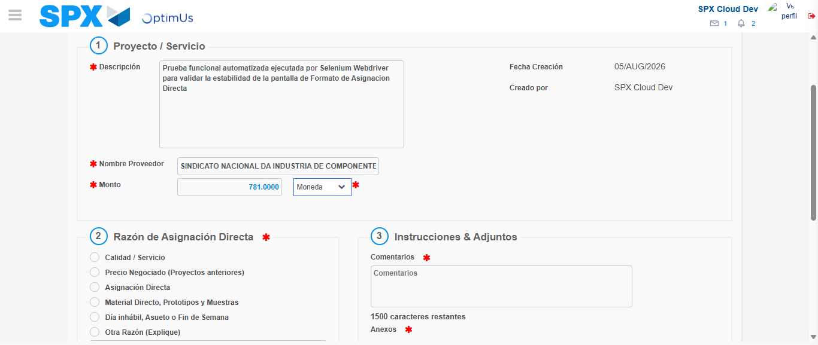Image file-name: QC_Testing-tc002_SPX_Dev5_Crear_Requisicion_Spot_Con_FAD_Tipo_Cobro_CC-1785975491284

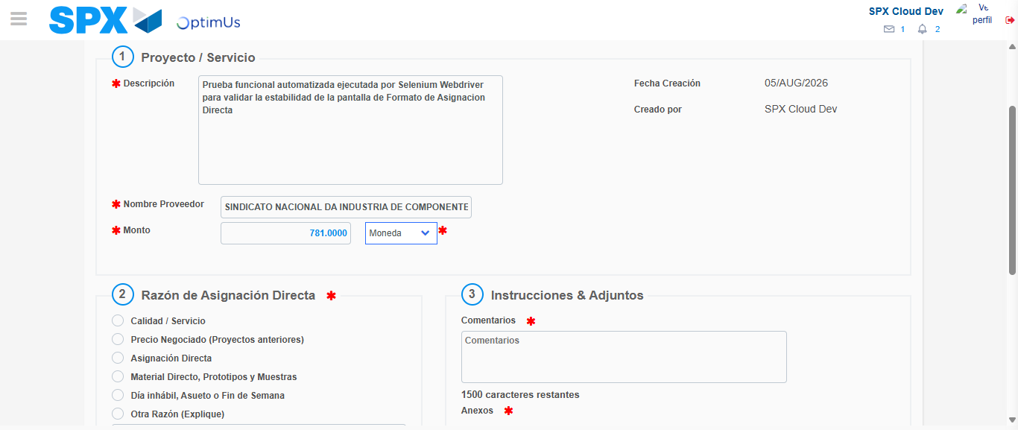Image file-name: QC_Testing-tc002_SPX_Dev5_Crear_Requisicion_Spot_Con_FAD_Tipo_Cobro_CC-1785975491499

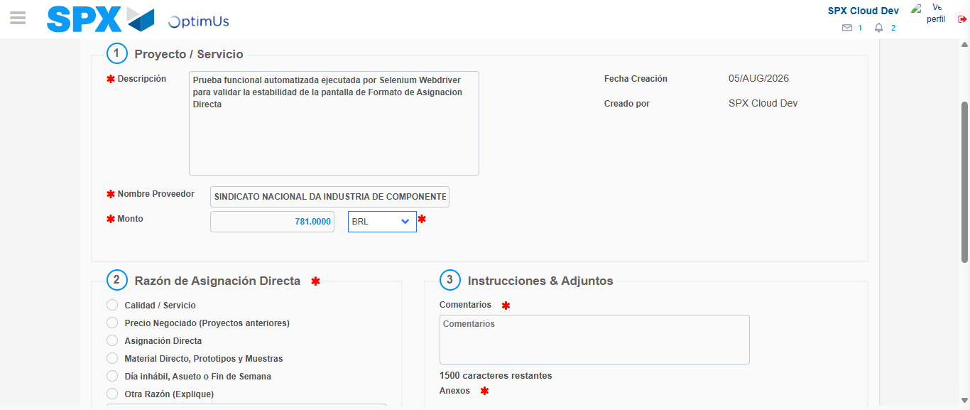Image file-name: QC_Testing-tc002_SPX_Dev5_Crear_Requisicion_Spot_Con_FAD_Tipo_Cobro_CC-1785975491931

Image file-name: QC_Testing-tc002_SPX_Dev5_Crear_Requisicion_Spot_Con_FAD_Tipo_Cobro_CC-1785975492178

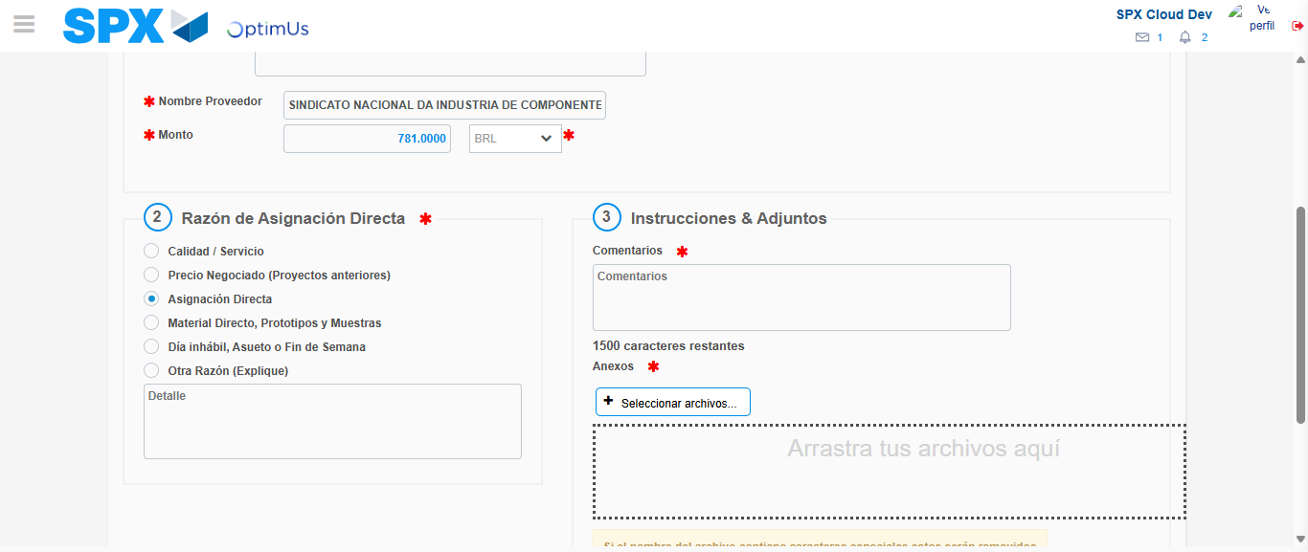Image file-name: QC_Testing-tc002_SPX_Dev5_Crear_Requisicion_Spot_Con_FAD_Tipo_Cobro_CC-1785975493180

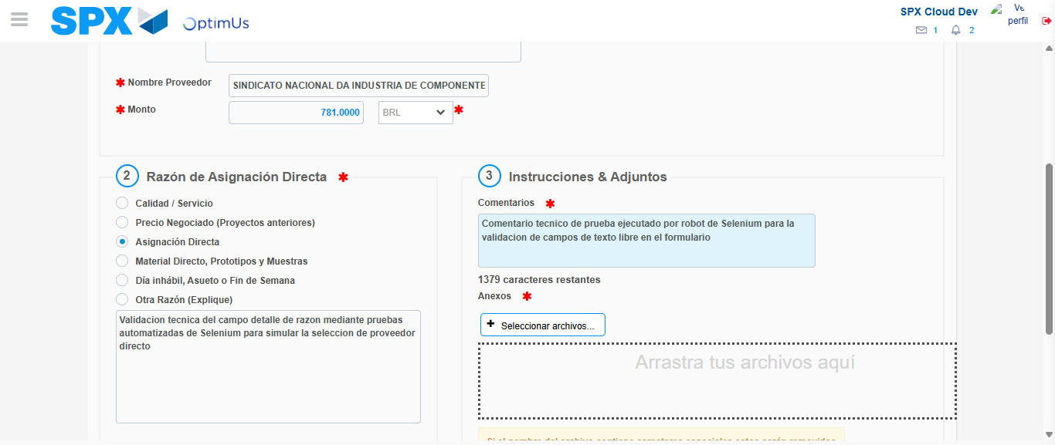Image file-name: QC_Testing-tc002_SPX_Dev5_Crear_Requisicion_Spot_Con_FAD_Tipo_Cobro_CC-1785975504534

Image file-name: QC_Testing-tc002_SPX_Dev5_Crear_Requisicion_Spot_Con_FAD_Tipo_Cobro_CC-1785975505391

Step 4 - Data Capture Spot Buy Requisition: Data captured correctly
Image file-name: QC_Testing-tc002_SPX_Dev5_Crear_Requisicion_Spot_Con_FAD_Tipo_Cobro_CC-1785975477013

Image file-name: QC_Testing-tc002_SPX_Dev5_Crear_Requisicion_Spot_Con_FAD_Tipo_Cobro_CC-1785975477220

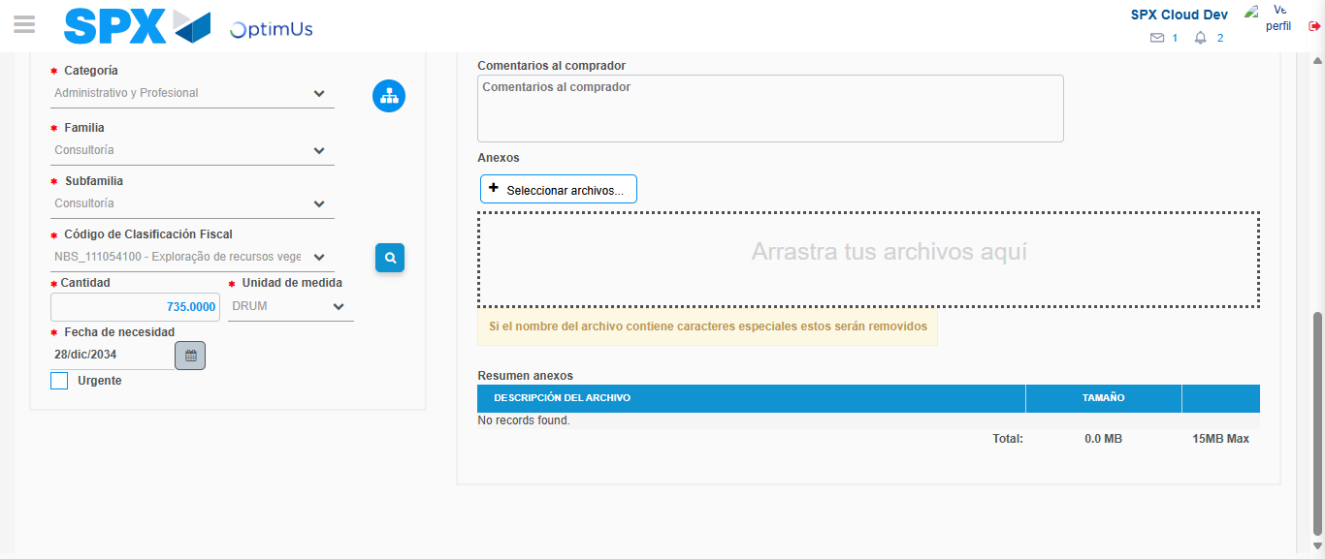Image file-name: QC_Testing-tc002_SPX_Dev5_Crear_Requisicion_Spot_Con_FAD_Tipo_Cobro_CC-1785975526230

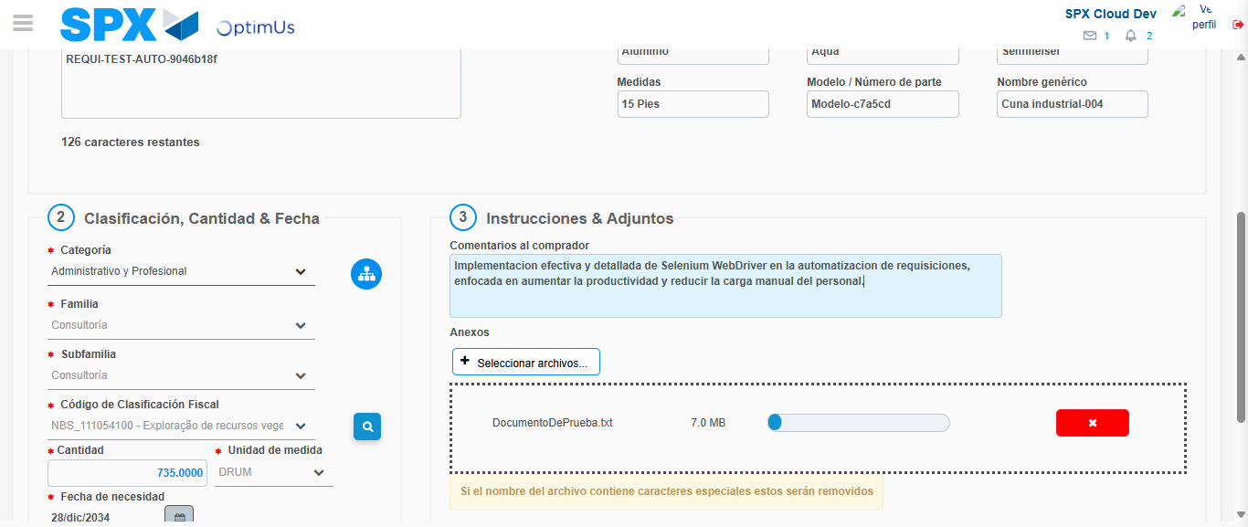Image file-name: QC_Testing-tc002_SPX_Dev5_Crear_Requisicion_Spot_Con_FAD_Tipo_Cobro_CC-1785975527231

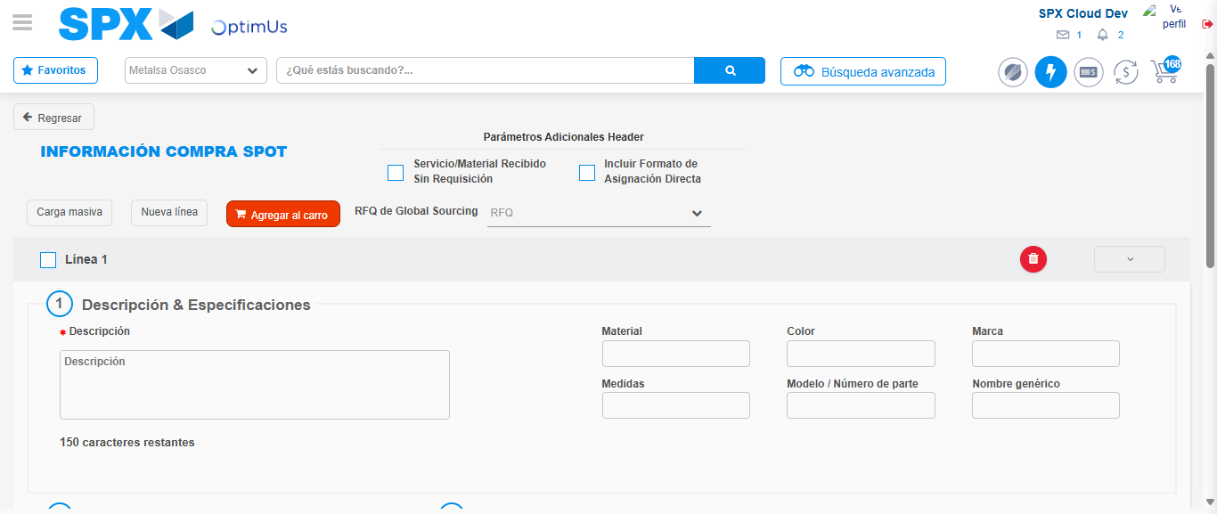Image file-name: QC_Testing-tc002_SPX_Dev5_Crear_Requisicion_Spot_Con_FAD_Tipo_Cobro_CC-1785975533390

Step 8 - Return to Main Page SPX : Return to Main Page SPX
Image file-name: QC_Testing-tc002_SPX_Dev5_Crear_Requisicion_Spot_Con_FAD_Tipo_Cobro_CC-1785975467027

Image file-name: QC_Testing-tc002_SPX_Dev5_Crear_Requisicion_Spot_Con_FAD_Tipo_Cobro_CC-1785975470164

Image file-name: QC_Testing-tc002_SPX_Dev5_Crear_Requisicion_Spot_Con_FAD_Tipo_Cobro_CC-1785975476714

Image file-name: QC_Testing-tc002_SPX_Dev5_Crear_Requisicion_Spot_Con_FAD_Tipo_Cobro_CC-1785975535636

Image file-name: QC_Testing-tc002_SPX_Dev5_Crear_Requisicion_Spot_Con_FAD_Tipo_Cobro_CC-1785975535796

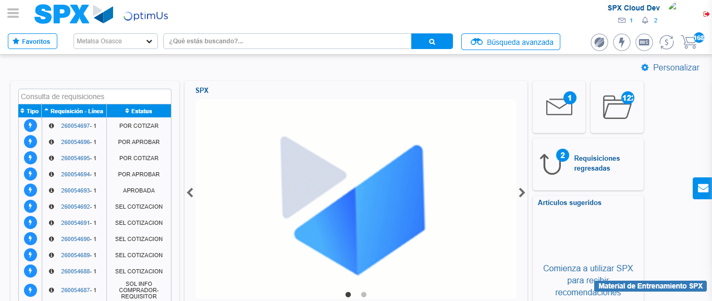Image file-name: QC_Testing-tc002_SPX_Dev5_Crear_Requisicion_Spot_Con_FAD_Tipo_Cobro_CC-1785975557022

Step 9 - Log Out : Log Out SPX
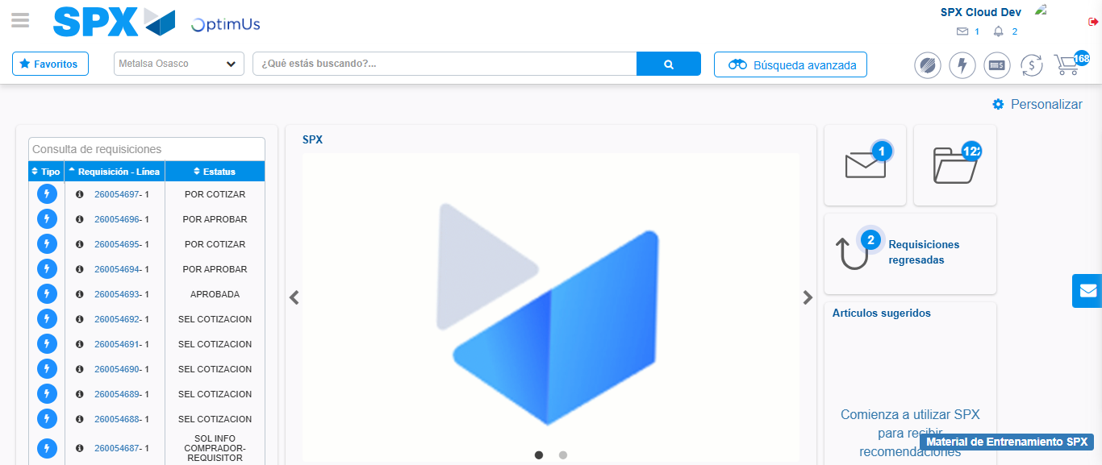Image file-name: QC_Testing-tc002_SPX_Dev5_Crear_Requisicion_Spot_Con_FAD_Tipo_Cobro_CC-1785975557409

